Weekly plan: 22.02.21 and 01.03.21
Year Group: Nursery
We would love to see what learning you’ve been doing at home! Please send photos in using the Evidence Me app. We also have a Nursery twitter page (@NurseryUmps) where you can share your learning with us and the rest of the school.
Daily Phonics tasks | Phonics: Speed sounds set 1  Revise the pictures for sounds: m, a, s, d, t, I, n, p, g, o, c, k, u, b, f, e. l, h, r, j, , v, y, w  - Help your child to recognise each picture for each sound.  zip exercise  The next picture cards we are going to learn about are made up of two pictures that the children have already learnt and should be familiar with. These picture cards all have a short story to go with them. Show your child the picture and tell them the story. Then when you show them the picture again, they can practise saying a simple sentence about it.  Story for ‘sh’: The snake is being really noisy! He keeps hissing and disturbing the horse. The horse turns to the snake and says “sshhhhhh! Be quiet!”  Practise saying: “Ssshhhhh!” says the horse to the snake.  Story for ‘th’: A lonely princess is locked away in a tall tower. She is very sad. One day a horse comes along and rescues her from the tower! The princess is very happy and says “thank you horse!”  Practise saying: The princess says “thank you!”  Story for ‘ch’: One day a cheeky little caterpillar meets his friend the horse. He crawls up the horse’s legs and body and onto his face. The caterpillar crawls under the horse’s nose. It’s very tickly! “Ch…ch…choo! The horse sneezes.  Practise saying: “ch...ch…choo!” The horse sneezes.  Story for ‘qu’: The queen is a very busy lady! She loves to go on long walks but it’s always raining! The queen doesn’t like to get wet so she always takes her umbrella with her.  Practise saying: The queen and her umbrella.  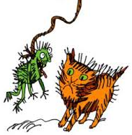  ng  Story for ‘ng’: The cat loves to play with his toys! One day his owner buys him a new toy to play with. It’s a thing on a string!  Practise saying: A thing on a string.  nk  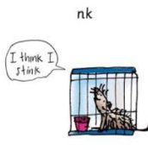  Story for ‘ng’: A rat lives on his own in his cage. After a few days, he needs a wash because he’s starting to get a bit dirty and smelly. The rat says to himself “I think I stink!”  Practise saying: “I think I stink!”  Oral blending  Collect some objects from around the house e.g. cup, mug, lid, fork, chair, pen, book, lamp, spoon.  Split each word up and say the sounds e.g. c-u-p then say cup. M-u-g then say mug. S-p-oo-n then say spoon.  Initial sounds  Play ‘I spy’ in your house. Say “I spy something beginning with b”. Can your child guess it’s a…(book).  Repeat with other initital sounds. ‘t’ = tv ‘p’ = plate ‘c’ = car ‘a’ = apple
Weekly Maths Tasks |  | Weekly Reading and Writing Tasks
Number Activities:  Counting  Practise counting up to and back from 10:  0, 1, 2, 3, 4, 5, 6, 7, 8, 9, 10  10, 9, 8, 7, 6, 5, 4, 3, 2, 1, 0  Count on from different numbers i.e  2, 3, 4, 5, 6, 7, 8, 9, 10  7, 8, 9, 10 4, 5, 6, 7, 8, 9, 10  Challenge: Can you count to 20?  Revise recognising numbers 0 – 5.  Practice forming these numbers using different media e.g. pencil, felt tp, sand, foam, chalk.  Comparing two groups of objects  For this activity you will need:  - 2 sorting hoops or 2 pieces of paper and draw big circle on each or 2 plates  - Small objects e.g. counters,coins, sweets, cheerios  - Number cards or pieces of paper of numbers 1 – 5 written on.  Place a small number of objects in each circle. Can your child compare the two groups by identifying which group has more.  Then ask which group has less/fewer  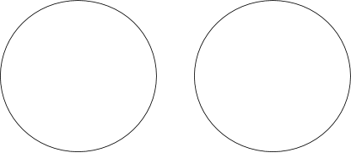  Now place the same number of objects in each circle. Ask: does one group have more?  No because they are the same.  Challenge: Can your child accurately count the objects in each circle and then select the correct number card? Start with numbers 1, 2 and 3. If your child can do this, have a go at numbers 4 and 5 too.  Complete this activity 3 or 4 times over the next two weeks, using different objects each time to keep practicing this skill. |  | Reading:  Parents to share a book with children daily. Visit Oxford Owl for free eBooks. You can create a free account.  Complete the linked Play activities for each book.  Share a story with your story: Dear Zoo  If you have the book, share the book with your child. If not, you can access the book on YouTube.  After you have read the story a few times ask questions about the story as you read with your child:  What animals did the zoo send?  What was wrong with each animal?  Which animal was a good pet?  Why was the puppy a good pet?  What happened at the beginning of the story… middle…end?  Can you join in with the story?  What do you like about the story?  Which animal was your favourite? Why?  What animal would you like for a pet? Why?  Writing:  Letters  Revise forming letters: m,a,s,t,d, i, n, p, g, o  Then practice forming the letters: c, k, u, b, f.  Follow the lines and say c-c-caterpillar, k-k-kangaroo, u-u-umbrella, b-b-boot, fffff-flower.  Use different media e.g. pencil, felt tip, sand, foam, chalk on the ground.  Name:  Write your child’s name on a big piece of paper and encourage them to trace over the lines.  Challenge: Encourage them to look at the shape of each letter. Can your child copy the letters underneath?

Topic based Activities: People Who Help Us
Talking and asking questions about different occupations
I am learning to ask questions about the world around me.
I am learning about different occupations and ways of life.
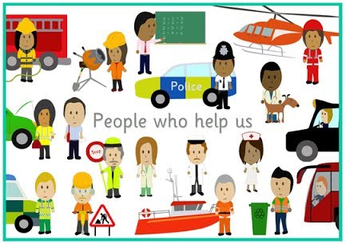
Encourage your child to talk about different people in their lives, and our world, who help them. There are lots of them. Here are some examples:
- Our parents and family
- Police
- Doctors and nurses
- Firefighters
- Vets
- Lollipop ladies and men

With your child see how many different people who help us you can name. How do these people help us? What do they do?

Look at some pictures of different occupations. You can do this by looking at pictures on the internet or in books. Model and encourage your child to think of some questions they might like to ask any of these people.
Examples: What do you do? Do you like your job? What’s your favourite part of your job? When do you work? Why did you want to be a ….? Who do you help?

If you have a close friend or family member who you and your child could call or video call, you could even get some answers to these questions!

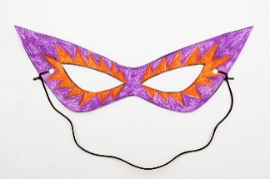
Creating your own superhero costume.
I am learning that tools can be used for a purpose.
I am learning to use available resources to create props to support role play.

We all love superheroes! They are fictional characters who are always very helpful. With you child have a look at some different superheroes, either pictures or toys.
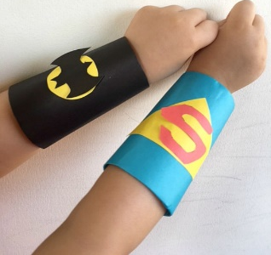
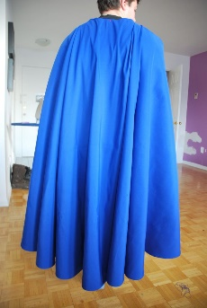
Who are they? What is their superpower? How do they help people? What do they wear?

Today we are going to become our own superhero and make our own costumes. Use pictures or toys of superheros as inspirations and talk with your child about what you might make. You can make anything you want and use resources that you have available.

You could make: a cape, headband, bracelet, mask, belt. Shield
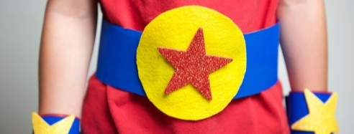
Resources you may need: glue, sellotape,bin liner, a hole punch, string, scissors, strips of coloured paper, material, crayons or felt tips, sequins, glitter.

Ordering and retelling the story of Dear Zoo.
I can listen to stories with increasing attention and recall.
I can join in with repeated refrains and anticipate key events in stories.
I can describe the main characters and events in stories.

Complete this activity in the week beginning 1st March, after you have read the story Dear Zoo a few times.

You can do this activity in one or both of the following ways:
1. Print off pictures of the animals in the story or…
2. Use toy animals that you have of the animals in the story.

Encourage your child to start telling the story…
“I wrote to the zoo to send me a pet. They sent me a…”

Encourage your child to retell the story as independently as possible. They can use the pictures or toy animals as prompts and put them in order as they retell the story.

Can your child retell the whole story? Have they remembered the key words from the story such as “too big”, “too tall”, “too scary”, “he was perfect”? What happened at the end of the story? Did they send the puppy back to the zoo? Why did they keep the puppy?

Get Active: Move like the Animals
I am learning to move freely with pleasure and confidence in a range of ways
I am learning to move around a space changing speed and my direction to avoid obstacles.
I am learning to say if I feel tired and hot

Clear a space in a room of your home, just enough so that there is space to move around without bumping into anything.
Talk about how different animals move
- Jumping like a kangaroo
- Hopping like a frog
- Running or jogging like a tiger
- Skipping like a monkey
- Crawling like a spider
- Slithering like a snake
- Shuffling like a whale
- Sliding like a dolphin

Chn to practice moving in these ways.
Talk about how they feel after some exercise. How do you feel? Is you heart beat fast or slow? Are you cold or hot?

Speed Sound Pictures Set 1 Diagraphs
nk
ng

Speed Sound Pictures Set 1

mmmm-mountain a-a-apple ssssss-snake d-d-dinosaur t-t-tower

i-i-insect nnnn-net p-p-pirate g-g-girl o-o-orange

c-c-caterpillar k-k-kangaroo u-u-umbrella b-b-boot ffffff-flower

e-e-egg lllllll-leg h-h-horse rrrrrr-robot j-j-jack in a box

vvvvv-vulture y-y-yak w-w-worm zzzz-zip exercise

Sounds m, s, n, f, l, r, v and z are all stretched sounds, e.g. ‘mmmmm’ and ‘sssssss’.
All other sounds are bouncy sounds, e.g. ‘a-a-a’ and ‘d-d-d’.
For the diagraphs (two letters, one sound), please see the stories and short sentences in the Daily Phonics Tasks section on Page 1.

